Table of Contents

1. PremiFIN General Features 2

2. General Ledger 3

2.1 Chart of Account 3

2.2 Account Structure 3

2.3 Consolidation 3

2.4 Integration 3

2.5 Reports 4

2.6 General Ledger 4

3. Accounts Receivables 9

3.1 Customer relationship 9

3.2 Invoicing 9

3.3 Payments 9

3.4 Reports 10

3.5 Integration 10

4. Accounts Payable 11

4.1 Supplier relationship 11

4.2 Invoice processing 11

4.3 Payments processing 11

4.4 Reports 12

4.5 Integration 12

5. Stock Control 13

6. Human Resources Management System 15

6.1 Personnel 15

6.2 Payroll 16

7. Technical Features 17

7.1 J2EE The Platform for Enterprise Solutions 18

# PremiFIN General Features

* Supports multi-currency, multi period and multi company operations.
* Allows the definition any number of branches/subsidiaries.
* Supports multi users access with many security levels.
* Easily Customizable
* Very Rich Functionality
* Tightly Integrated modules
* Adaptation of state of the art technology “J2EE”
* Web Based ERP Solutions
* Proven Development, Project Management, and Quality Assurance Methodologies
* Localized to the Egyptian market standards.
* Adequate After Sales Support/maintenance level

# General Ledger

PremiFIN General Ledger is designed to meet both the current and the future financial needs of any organization. Its open and flexible architecture gives you a foundation upon which to build and adapt to the changing business needs. Many features and reports are user-defined to generate better performance and smoother customization.

## Chart of Account

The user can define his own chart of accounts with the different account types (Assets, Liability, Expense, Revenues, etc.) without any limitations. He can define multiple organizations including unlimited structures, unlimited levels and multiple hierarchies. The accounting calendar is up to 999 periods while the General Ledger is a multi-year system. There is no need to close your books before continuing with a subsequent period. PremiFIN General Ledger handles inter-company accounting, reversing journals, recurring journals and standard journals. Being a multi-currency system, it maintains internally the balances of all General Accounts in foreign and base currencies.

## Account Structure

The system allows the using of free coding of account numbers. It also allows the user defined account segments. Examples of legal and analytical accounting segments include cost center, department and project. The setup contains rules, where you can specify how segments can be combined. You can also define reporting levels for a number of segments. These can accurately mirror your company structure. Examples include grouping geographical areas into districts, regions and countries.

## Consolidation

You may want to consolidate your subsidiaries into the Group’s accounts. The system allows you to define the order and depth for consolidation of different financial positions of different business units or companies.

## Integration

The General Ledger system is the basis for all integration with other PremiFIN systems. The journal entries related to the other systems (Stock Control, Sales,

Purchasing ...etc) are automatically generated and imported to the general ledger files. The General Ledger system can also function as a stand-alone.

## Reports

PremiFIN General Ledger provides a host of standard reports, such as trial balances, transactions lists, journal entries, ..etc. These reports can serve as templates for your own reports.

## General Ledger

The general ledger classifies and summarizes all financial activity and provides the ability for financial reporting.

1. **Length of account number (key)** - The maximum length of the general ledger account number.
2. **Account number is free format** - The user specifies the format (i.e. embedded hyphenation, etc.).
3. **Variable accounting periods** - The user specifies the accounting cycle on which the organization works (i.e. 12 or 13 periods per annum).
4. **Prior period posting** - Allows the prior period to be kept open while posting to the current period. This is normally an important feature for maintaining timely update:-
   * Prior year - Allows posting to the prior year whilst posting to current.
   * Posting new month before close of old month.
   * Posting new year before close of old year.
5. **Manual journal entries** - The manual posting of journal entries.
6. **Data elements maintained** - the following fields are maintained:-
   * Journal voucher number - Source Journal reference number used as an audit trail.
   * Journal entry. Refers to journal entry source.
   * Account number - GL account number where journal activity is to be posted.
   * Company - Company and/or companies to post journal entry.
   * Responsibility centre - The individual assigned in the system responsible for managing the integrity of transactions.
   * Journal description - Supplement to the journal entry to describe purpose and source of the entry. The description prints on the general journal only.
   * Line entry description - Description used when the journal entry is posted to the general ledger. Provides general ledger user with basic concept of the entry without referencing the general journal.
   * Batch number - signifies the batch from which the entry was created. This is useful when investigating source documents supporting the journal entry.
   * Source number - Source journal reference number where the journal entry was created. Provides an easily distinguished audit trail for the entry.
   * Transaction date - Account date used when the entry is posted to the general ledger to identify the accounting period when the transaction occurred.
   * Accounting periods - Accounting dates to separate/distinguish timing of transactions. For example, "For The Six Months Ended June 31, 199X".
   * Entry date - The actual date the entry was physically entered into the system as opposed to the accounting date the transactions occurred.
7. **Maintain accounts in foreign currency** - Posting, tracking and identification of accounts in currencies other than Australian Dollars. For example, Japanese Yen, American Dollars or Deutschemark. This is useful when a company has business operations in a foreign country.
8. **Foreign Currency Conversion** - The ability to convert foreign currencies into dollars. Features include:-
   * Current exchange rate - The ability to modify/maintain most current rate of exchange of a fluctuating foreign currency.
   * Average exchange rate - The ability to average fluctuating foreign currencies over a specified period of time as the different rates are being maintained.
   * Historical exchange rate - Retention of exch. rates as they have been maintained over a period of time.
   * Automatic translation to current - Recalculation of a foreign currency exchange rate from a previous time period to the current.
   * Foreign Currency Consolidation into base currency - The ability to automatically consolidate into financials using base currency as standard.
9. **Report financial in domestic and foreign currencies** - Conversion, calculation and reporting of financial information from one currency to an other concurrently.
10. **Cash basis system** - Recording of revenues and expenses according to actual cash flow (when revenues are received and expenses are paid) as opposed to accrual basis accounting where revenues are recognized when earned and expenses are recognized when incurred.
11. **Delete and re-enter journals** - The ability to delete and/or re-enter a journal entry after the entry has been posted to the system
12. **Multiple companies (number handled)** - Allows the separate control and tracking over more that one company and the consolidation into a corporate statement:-
    * Multi receivable accounts - Separate accounts receivable data for revenue.
    * (summarized into one corporate account).
    * Multi accounts payable - Separate accounts payable data for expenses.
    * (summarized into one corporate account).
    * International vs Domestic.
    * Eliminating entries for consolidation - .Performs the eliminating entries when consolidating.
13. **Ledgers:-** Maintain statistical data - Maintenance of account information with application of formulae applied to the data. Examples of such statistical data would be financial ratios, year-to-date accumulations, etc
    * Number of statistical data fields - The initiation of user defined fields which can be used to accumulate data used for subsequent reporting. Samples include, month-to-date or year-to-date fields.
    * Report operating statistics - Statistical information derived from financial report data used to analyze operations, such as, current ratios, quick ratios, etc…
    * Multiple years balances - Maintenance and comparison of current balances to those of the prior year(s).
    * Purge balances under user control - Deleting specific historical data no longer required within the system. This is often necessary for
    * efficient use of computer space for information that has been hard copied.
    * Account balance data - The ability to retain detailed account information:-
    * Company refers to specific company which the account balance information is related.
    * Account is the specific account to which the account balance information is related.
    * Responsibility is the resource centre responsible for maintaining the integrity of the account.
    * Accounting year refers to accounting dates the account balance information is derived from.
    * Monthly ending balances applies to specific month end balances of accounts.
    * Y-T-D balance/activity equates to Y-T-D balances and/or activity of accounts throughout the year.
    * Prior year ending balances is retention of prior year balances of accounts.
    * Prior year Y-T-D balances are balances and/or activity retained in the system through the end of the subsequent year.
14. **Foreign currency ledger** - The retention of a ledger specified in one or more foreign currencies.
15. **Amount field size** - Maximum number of characters allowed in the field. Example of such would be a 9 character field which would retain amounts up to $9,999,999.99.
16. **Reports** - Information displayed in hard copy (paper) form:-
    * Income statements - Statement of Revenues and Expenses for a specified period of time compiled on an accrual basis.
    * Balance sheet - Statement of assets, liabilities and capital at a particular point in time.
    * Consolidating by company - Combined balance sheet more than one company with the elimination of inter-company debt and investments.
    * Trial balance - Identification of each general ledger account, listing the account ending balance at a particular date.
    * Profit & Loss - Statement presenting net income or loss from operations before non-cash items (depreciation and amortization).
    * General ledger detail - Transaction history for each account during a specifiec period of time.
    * Y-T-D periods - Year-to-date balances by period for general ledger accounts.
    * By detailed G/L account.
    * By trial balance.
    * By transaction impact. o Sort options.

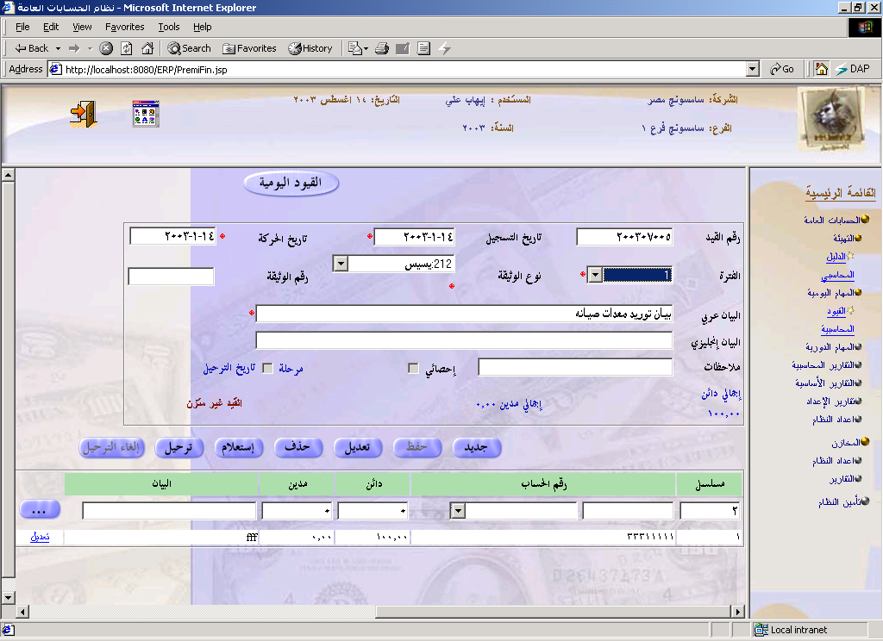

# Accounts Receivables

The Accounts Receivable system (AR) not only allows better collection control but also gives you the tool to achieve your financial and business goals. PremiFIN Accounts Receivable system gives you the power and flexibility you need to manage high payments volumes. Based on the rules you define, the system will automatically do the accounting for all your receipts including cash, checks, and miscellaneous receipts and adjustments. The system will allow you to follow-up the AR positions, including period and year balances, foreign currencies positions and local equivalents, transactions total per transaction class (Invoices, collections, returns, refunds, debit notes, and credit notes.)

## Customer relationship

You can specify each customer profile and create customer credit profiles and payments terms and conditions. You can enter an unlimited number of addresses, foreign or domestic, remit-to addresses, contact names, telephone numbers, ..etc. The system will display customer related information at transaction entry. Customer statement can be printed at any time.

## Invoicing

PremiFIN Accounts Receivable handles different transaction classes including Collections, Invoices, Debit Notes, and Credit Notes. You can allocate DR transactions with CR transactions, either during the first entry of a transaction or later on. Allocation from a transaction can be for the full amount or only partial amount, (enabling multiple DR transactions to allocate from a CR transaction). The system will handle write-off s’, return invoices and refunds.

## Payments

The system can automatically distribute payment vouchers on customer pending invoices using FIFO method; manual distribution by the user is also available. Payments discounts will be treated according to user-defined rules, depending on invoice date, payment terms and conditions, and payment date. Customer’s over-dues are automatically tracked by the system; aging reports are generated for every customer.

## Reports

PremiFIN Accounts Receivable assists you with a number of reports. These include customer statement of account, debt aging, inactive customers, customer balances, consolidated balances, and customer’s statistical information.

## Integration

PremiFIN Accounts Receivables can be used as a stand-alone, or integrated with General Ledger. The Accounts Receivable system is required, if you want to use the Sales Order system.

# 

# Accounts Payable

PremiFIN Accounts Payable system (AP) helps you make effective payments decisions, and coordinate purchasing and authorization routines. It will improve your cash management by making it easy for you to control cash disbursement of funds, keep your accounting records up-to-date, and maintain a good relationship and credit standing with your suppliers.

## Supplier relationship

You can specify each supplier profile and the terms of payment. This helps you resolve business issues quickly by providing immediate and accurate responses to the supplier inquiries. You can record detailed information about your suppliers, including their payments, and invoice processing preferences.

## Invoice processing

Incoming invoices can be preliminary entered into the system, and then wait for authorization. You can define the rules for approvals, including the maximum amount for each user. The system allows you to carryout hold on invoices, including partial holds, based on user-defined hold reasons.

## Payments processing

The system will follow the payment terms defined for each supplier, and will calculate payment discounts as applicable. The user can manually distribute the payment voucher on pending invoices, or the system can do it automatically using FIFO method. Payments can be made in local currency or foreign currencies; the system will calculate currency gains and losses. You can place holds on payments by supplier, or by invoice. Once all reviews and approval steps are completed, payment checks are automatically printed by the system.

## Reports

PremiFIN Accounts Payable assists you with a number of reports. These reports include supplier statement of account, inactive suppliers, supplier balances, consolidated balances, and supplier’s statistical information.

## Integration

PremiFIN Accounts Payable can be used as a stand alone, or integrated with General Ledger.

# Stock Control

Handles functions related to the tracking and management of material. This would include the monitoring of material moved into and out of stockroom locations and the reconciling of the inventory balances.

1. Multiple stocking locations (keys) - Items stored in more than one location and identified separately by warehouse, bin, etc. Size of the key field for identification.
2. Size of on-hand field - The number of positions that can be entered for quantity values.
3. On-hand decimal precision (number) - Indicates if the system supports other than whole numbers for stocking quantities. Number of decimal places are specified.
4. Number of on-Hand Categories - On-hand control areas may be dissociated into various functional elements such as inspection, MRB, receiving, quarantine, floor stock, etc. Lists the number of user defined categories.
5. Inventory valuation - The ability to value inventory by various options and select the option to affect transactions.
   * FIFO - First In First Out.
   * LIFO - Last In Last Out (not allowed in Australia).
   * Average Cost inventory valuation.
   * Actual Cost inventory valuation.
6. Inventory adjustments - The capability of adjusting inventory balances without the need to issue items to a specific order. This is commonly used to adjust stockroom balances after a physical inventory count. In addition it may be used to issue material to an expense account, e.g. to the engineering department.
   * Negative on-hand allowed refers to the system permitting display and retention of negative values usually resulting from out of logical order transaction processing.
   * Non-access flags prohibit use of the lot.
7. Min-max inventory control - Allows the control of material by specifying minimum and maximum stocking levels.
8. Safety stock logic - Logic to calculate the quantity of parts that should be in stock at all times to provide a buffer for unanticipated demand.
9. Safety lead time logic - Safety stock expressed as inflated lead-time as a buffer for late deliveries.
10. Usage-to-date accumulation - Tracks total usage quantity of a part.
11. Shipped-to-date - The tracking of the total shipped quantity of a part.
12. On-order outstanding accumulation - The sum of all replenishment orders open for a part.
13. Inquiries - Information displayed on the terminal.
    * Stock status by item - On hand inventory of specified items.
    * Stock status by location - A display of on hand inventory of items stored in a specified location.
    * Stock status by lot - A display of on hand inventory of items stored for a specified lot.
14. Reports:
    * Stock status by item - On hand inventory of specified items.
    * Stock status by location - On hand inventory of items stored in a specified location.
    * Cost book - A report on the item master with costs for each part.
    * Report totals - Indicates if the system provides a summary on appropriate reports.
    * Monthly transaction register - A display of the on line transaction audit trail provided by user specified time periods for prior "months" of history.
    * Pick (Material) list - A display indicating which components are needed, in what quantities, and from what locations to satisfy an individual order.

# Human Resources Management System

## Personnel

The personnel module of PremiFIN keeps track of the personnel information and maintains a complete and accurate database of all the vital personnel information such as personal records, insurance data and allowances.

**Personal Records**

You can specify the different kind of employee data using the personnel module:

Personal Information, demographic information, education, contact details,..etc.

**Allowances**

The system gives the user the ability to define different and customizable allowances types.

**Job Position**

The system is very flexible in defining Job in an Organization Unit with different Job descriptions.

**Employee Classification**

Each employee can be classified according to the employee category with the option of being assigned earnings/deductions. Job Class based on the related work of the employee classifies the Jobs in a hierarchy.

**Salary/Promotion/Penalty**

Job Categories have the option of being assigned maximum or minimum salary ranges One of the features of the system is the ability to perform violation & penalties transactions. Another feature of the system is the performance evaluation where the employee is evaluated according to defined evaluation elements. The manager of the system can also specify the promotion , job change, department reallocation or internal transfer categories for a particular employee.

## Payroll

The Payroll module of PREMIFIN is designed to cover all the vital payroll transactions within a company. It helps eliminate or diminish the administration costs. This system makes the payroll information more accurate and organized, and takes into account the periods of the payment cycles and the changes that continuously occur to the employee position, job, salary, etc.

**Payroll Cycles**

The Payroll Cycles/Periods are user defined and have the option of being either like or different from the Accounting periods. These Cycles/Periods can be auto-generated into months, weeks in Gregorian calendar formats.

**Payment Periods**

The system can generate multiple payments to an employee for any specified payment period. In addition, payments can be generated according to Gregorian

The system provides the option of automatically generating payments for salaries and other periodic payments/deductions (Schedule & Auto release recurring payments / deductions).

**Monthly Payroll**

The Payroll module can prepare monthly payroll based on compensation items/deduction and overtime in addition to computing the actual end of service for an employee upon termination of employment.

**Pay slips**

One feature of the system is its ability to generate payslips according to employee number, cost center or location s well as to issue payment and receipt orders.

**Trial Run**

One of the important features of PremiFIN is its generation of a trial Run of payroll before it is finalized and its automatic update of employee leave entitlements and ticket balance, which is based on cumulative (carry forward) flag.

**Payroll Changes**

The system can record changes in employee position, promotion, demotions, change in compensation from a user specified date and the compensation items will be automatically computed accordingly.

# Technical Features

Premitek deploys the best of breed technology namely J2EE to develop and build its application systems. Our PremiFIN solution is a Java web based system which means that the business logic layer and presentation layer are deployed on a central application server (or multiple depending on the organization size and volume of data). This enables a user with a browser and right privileges to access the application without the need of installing any client software. Our application can also be easily deployed on the internet which enables our clients to easily adapt e-commerce initiatives whether B2B or B2C.

The J2EE technology facilitates the deployment of our system on any operating system with no changes to its application code, this includes Windows, Unix, Linux,..etc. Moreover, our standard connectors give our clients the option to select any back-end RDBMS including Oracle, MS SQL server, IBM DB2, MySQL, PostGres, MS Access,..etc

**PremiFIN System Technical Architecture**

**HTTP over TCP/IP**

**Back End Connectors (JDBC)**

**Business Logic Components (EJB)**

**Web Server**

**Internet Explorer or Netscape Browser**

**Internet Explorer or Netscape Browser**

**Back-End**

**Database**

**Application Server**

**Internet Explorer or Netscape Browser**

## J2EE The Platform for Enterprise Solutions

The Java 2 Platform, Enterprise Edition (J2EE) defines the standard for developing multi-tier enterprise applications. J2EE simplifies enterprise applications by basing them on standardized, modular components, by providing a complete set of services to those components, and by handling many details of application behaviour automatically, without complex programming.

The Java 2 Platform, Enterprise Edition, takes advantage of many features of the Java 2 Platform, Standard Edition, such as "Write Once, Run Anywhere" portability, JDBC API for database access, CORBA technology for interaction with existing enterprise resources, and a security model that protects data even in internet applications. Building on this base, Java 2 Enterprise Edition adds full support for Enterprise JavaBeans components, Java Servlets API, JavaServer PagesTM and XML technology. The J2EE standard includes complete specifications and compliance tests to ensure portability of applications across the wide range of existing enterprise systems capable of supporting J2EE.

**Making Middleware Easier**

Today's enterprises gain competitive advantage by quickly developing and deploying custom applications that provide unique business services. Whether they're internal applications for employee productivity, or internet applications for specialized customer or vendor services, quick development and deployment are key to success.

Portability and scalability are also important for long term viability. Enterprise applications must scale from small working prototypes and test cases to complete 24 x 7, enterprise-wide services, accessible by tens, hundreds, or even thousands of clients simultaneously.

However, multitier applications are hard to architect. They require bringing together a variety of skill-sets and resources, legacy data and legacy code. In today's heterogeneous environment, enterprise applications have to integrate services from a variety of vendors with a diverse set of application models and other standards. Industry experience shows that integrating these resources can take up to 50% of application development time.

As a single standard that can sit on top of a wide range of existing enterprise systems -- database management systems, transaction monitors, naming and directory services, and more -- J2EE breaks the barriers inherent between current enterprise systems. The unified J2EE standard wraps and embraces existing resources required by multitier applications with a unified, component-based application model. This enables the next generation of components, tools, systems, and applications for solving the strategic requirements of the enterprise.

With simplicity, portability, scalability and legacy integration, J2EE is the platform for enterprise solutions.